Static Timing Analysis

Lab1: Generating Timing Reports

Objective
To study:
- Generating timing reports
- Generating worst path timing reports.

Laboratory task

- Load Gate Level design into PrimeTime
- Generate worst path timing reports
- Generate timing report for specific path.
Supporting information for doing laboratory work
Laboratory work is performed on a gate level design generated by compiling given RTL code (Listing 1.1) using Design Compiler (Fig 1.1). Sample SDC file is also provided as reference (Listing 1.2).
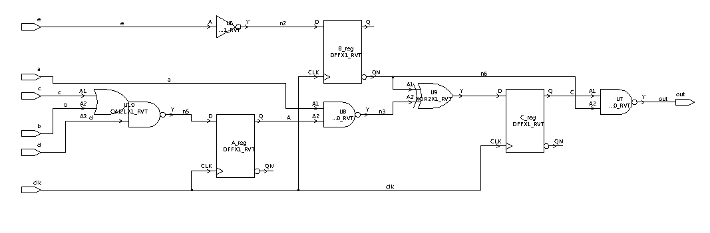
Fig. 1.1. A Sample Circuit

Listing 1.1 Example Circuit RTL (circuit.v)
module circuit (a,b,c,d,e,clk,out);
input a;
input b;
input c;
input d;
input e;
input clk;
output out;
reg A;
reg B;
reg C;

assign f= ~(d&(c|b));
assign g=~e;
assign h= ~B|~(a&A);

assign out= ~( ~(B) & C);

always @ (posedge clk)
begin
A= f;
B= g;
C= h;
end

endmodule

Listing 1.2 Sample Circuit Constraints (circuit.sdc)
set_load -pin_load 0.04 [get_ports {out}]

create_clock [get_ports clk] -period 10 -waveform {0 5}
set_clock_uncertainty 0.4 [get_clocks clk]
set_propagated_clock [get_clocks clk]
set_clock_transition -rise 0.8 [get_clocks clk]
set_clock_transition -fall 0.8 [get_clocks clk]
set_input_delay -clock clk 5 [get_ports a]
set_input_delay -clock clk 5 [get_ports b]
set_input_delay -clock clk 5 [get_ports c]
set_input_delay -clock clk 5 [get_ports d]
set_input_delay -clock clk 5 [get_ports e]
set_output_delay -clock clk 8 [get_ports {out}]

1. Loading Gate Level design into PrimeTime
First load design along with constraints into PrimeTime. Below is a sample script to it.

set link_library ../liberty/saed05nlplogl06hdl060f_tt0p75v25c.db
read_verilog ./circuit_gate.v
read_sdc circuit.sdc

2. Generating worst path timing reports
Generate timing reports using report_timing command for max and min delays. These commands will report paths with worst slack for minimum and maximum delay respectively.

report_timing -delay_type max
report_timing -delay_type min

An example of a report is shown below:
****************************************
Report : timing
-path_type full
-delay_type max
-max_paths 1
-sort_by slack
Design : circuit
Version: S-2021.06-SP4
Date : Tue Dec 13 10:00:10 2022
****************************************

Startpoint: B_reg (rising edge-triggered flip-flop clocked by clk)
Endpoint: out (output port clocked by clk)
Path Group: clk
Path Type: max

Point Incr Path
---------------------------------------------------------------
clock clk (rise edge) 0.00 0.00
clock network delay (propagated) 0.00 0.00
B_reg/CK (SAEDSVT05_FDPQ_1) 0.00 0.00 r
B_reg/Q (SAEDSVT05_FDPQ_1) 0.00 0.00 f
U10/X (SAEDSVT05_INV_1) 0.00 0.01 r
U9/X (SAEDSVT05_ND2_1) 0.00 0.01 f
out (out) 0.00 0.01 f
data arrival time 0.01

clock clk (rise edge) 10.00 10.00
clock network delay (propagated) 0.00 10.00
clock reconvergence pessimism 0.00 10.00
clock uncertainty -0.40 9.60
output external delay -8.00 1.60
data required time 1.60
---------------------------------------------------------------
data required time 1.60
data arrival time -0.01
---------------------------------------------------------------
slack (MET) 1.59

Timing report shows required and arrival times for the worst path (min or max) as well as calculated slack.

3. Generating timing report for specific path
Use report_timing -from { e} -to { B_reg/D } command for specific path timing report.

Report
The report should have:
- Design Compiler and PrimeTime scripts
- The gate level circuit
- Worst path timing reports
- Timing reports for specific paths
- Brief summary.

